**Programming 2 Exercise 1**

What is the object-oriented example?  
For example, say we created a class, Car, to contain all the properties a car must have, color, brand, and model. We then create an instance/behavior/method of a Car type object, myCar to represent my specific car.  
Could you please create another 5 object-oriented examples and give all their properties and their instances/behavior/method?

1. Cat

Properties:

1. Breed

2. Colour

3. Coat

4. Size

Class:  
Cat

Behaviour:

1. Walk()

2. Run()

3. Sleep()

4. Eat()

Breed: Sphynx cat

Colour: Skin colour

Coat: Furless

Size: Medium

Breed: Ragdoll

Colour: White-pointy

Coat: Yes

Size: Large

Breed: British shorthair

Colour: Grey-blue

Coat: Yes, with dense coat

Size: Medium

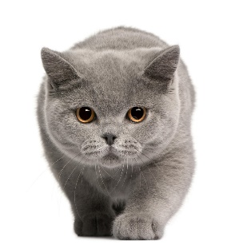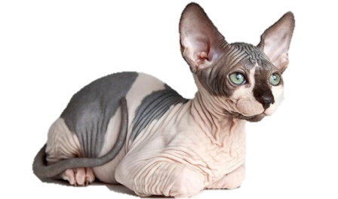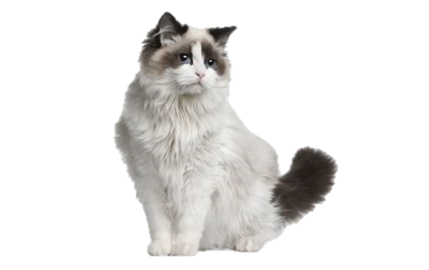

2. Smartphone

Properties:

1. Model

2. Operating system

3. Released year

4. Brand

Class:  
Smartphone

Behaviour:  
1. Notification()

2. Mute()

3. Screenshot()

4. Recordscreen()

Model: Galaxy Note 8

Operating system: Android 9.0

Released year: 2017

Brand: Samsung

Model: iPad 10.2 (2020)

Operating system: iOS 14.4

Released year: 2020

Brand: Apple

Model: iPhone X

Operating system: iOS 14.4

Released year: 2017

Brand: Apple

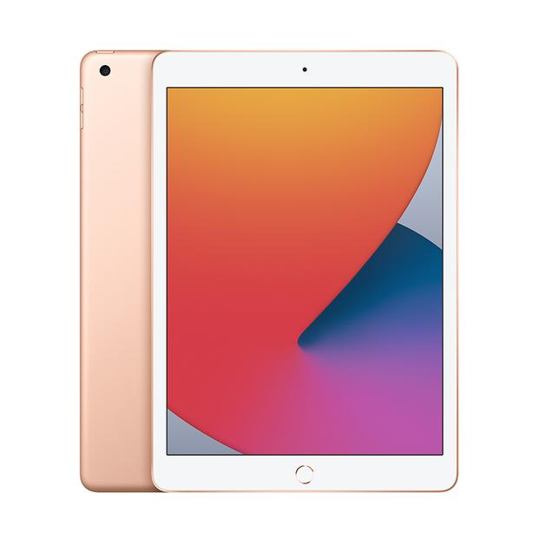

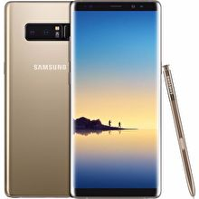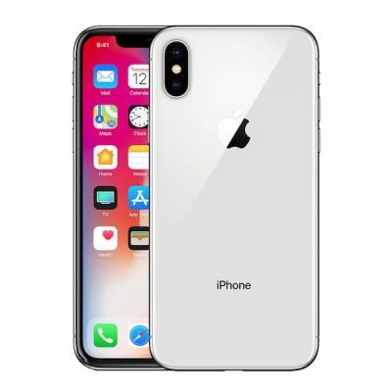

3. Air conditioner

Class:  
Air conditioner

Properties:

1. Brand

2. Model

3. Size

4. Portable

Behaviour:  
1. Coolmode()

2. Fanmode()

3. Timer()

4. Silentfan()

Brand: Samsung

Model: 1.5HP S-Essential AR12TGHQABUNME

Size: 870x270x365

Portable: No

Brand: Midea

Model: AAC12AR

Size: 736x330x380

Portable: Yes

Brand: Sharp

Model: 1.0HP R32 AHA9XCD

Size: 773x250x185

Portable: No

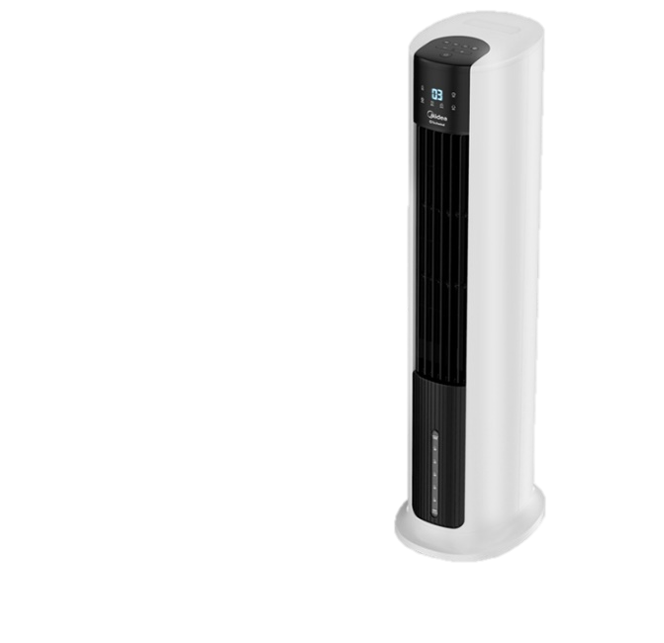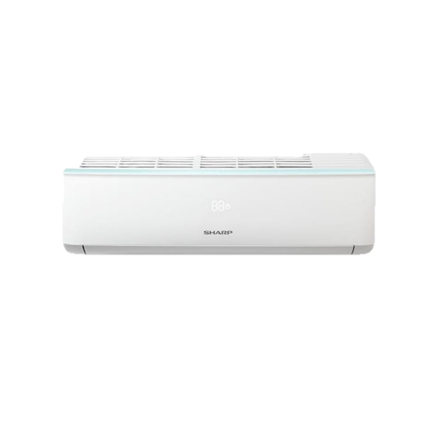

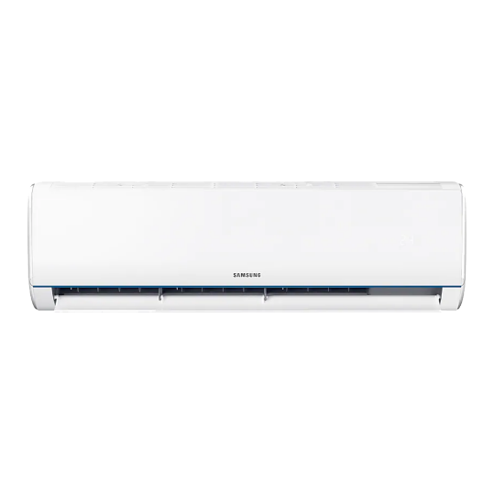

4. Keyboard

Class:  
Keyboard

Properties:  
1. Brand

2. Model

3. Numpad

4. Bluetooth

Behaviour:  
1. backspace()

2. capslock()

3. shift()

4. enter()

Brand: Razer

Model: Huntsman Elite V Optical

Numpad: Yes

Bluetooth: No

Brand: Logitech

Model: K120

Numpad: Yes

Bluetooth: No

Brand: Raspberry Pi

Model: 400

Numpad: No

Bluetooth: Yes

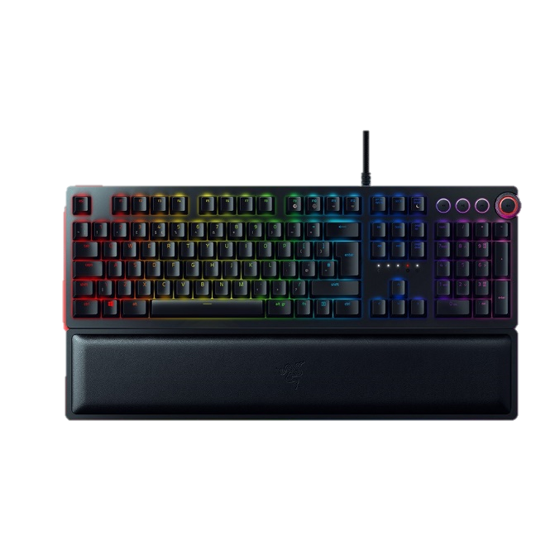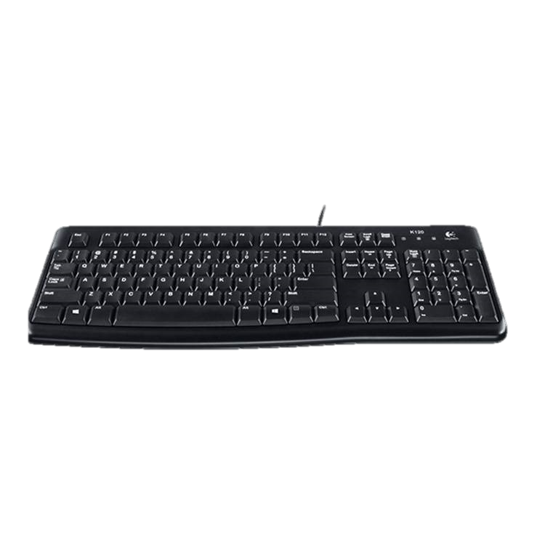

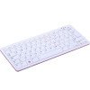

5. Printer

Properties:

1. Brand

2. Model

3. Bluetooth

4. Scanner

Class:  
Printer

Behaviour:

1. Colour()

2. Black()

3. DirectPhone()

4. Network()

Brand: HP

Model: Smart Tank 515

Bluetooth: Yes

Scanner: Yes

Brand: Brother

Model: PTP900W

Bluetooth: No

Scanner: No

Brand: Canon

Model: G3010

Bluetooth: No

Scanner: Yes

